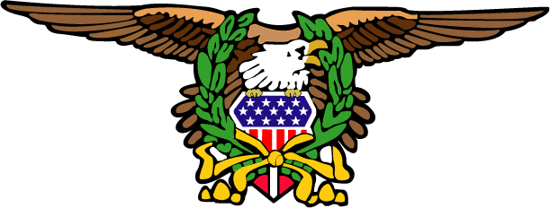
ABATE of New York, Inc., P.O. Box 1417, Northville, NY 12134
www.abateny.org

abateny.org
Dedicated to Freedom of the Road

Date

Legislator Name/Address

Re: (Bill name and number)

Dear (name)
As a member of ABATE (American Bikers Aimed Toward Education) of New York, I am writing to you as your constituent and voter regarding the above bill.

In case you are not aware, ABATE is a nationwide organization with state and individual county chapters. We are not a "motorcycle club" - we are a group of individuals from different backgrounds coming together to ensure that the rights of all motorcycle riders are protected. We do this by making sure that the motorcyclists' point of view is presented to our legislators.

We encourage all our members to be informed, registered voters. We write letters to our elected officials and stay aware of what is going on with motorcycle legislation, education, and other transportation issues. We pay very close attention to how motorcyclists and laws relating to motorcycles are supported by you, our elected officials. We also spread the word about motorcycle safety, awareness, and education.

We (support/oppose) the above bill for the following reasons: (insert position paper language here)

Sincerely yours,

(name and chapter information)

